Call for Proposals
Break the Cycle of Children’s Environmental Health Disparities:
Promoting Health Equity for All Children
18th Annual Program

Hosted by
Southeast Pediatric Environmental Health Specialty Unit at Emory University and
Break the Cycle of Health Disparities, Inc.

Children who grow up in circumstances of social and economic disadvantage are at greater risk for exposure to adverse environmental factors and are more likely to suffer adverse health and developmental consequences. These adverse consequences persist into adolescence and adulthood and not only affect health, wellbeing, and longevity, but also affect education and employment opportunities which results in limited earning potential. The limited income, in turn, reduces access to necessary resources for their children, this perpetuating poverty, and an intergenerational Cycle of Health Disparities (see cycle diagram below).

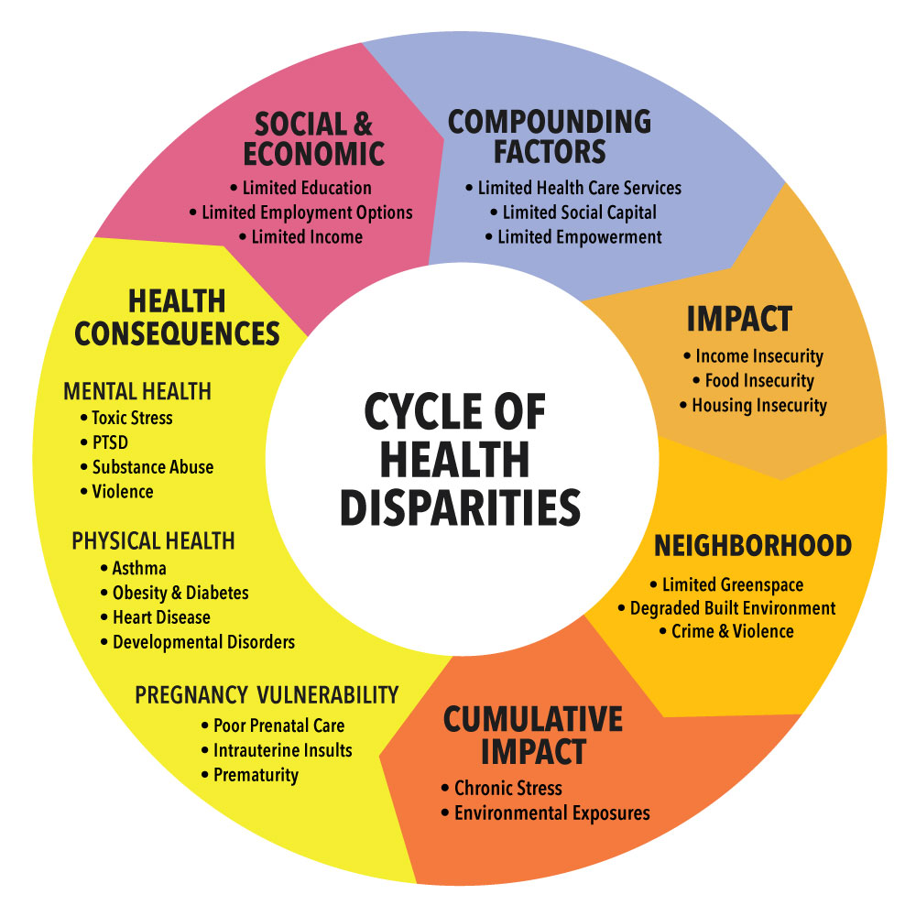

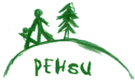

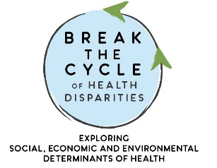

BREAK THE CYCLE FACULTY
I. Leslie Rubin, MD
Abby Mutic, PhD, MSN, CNM
Nathan Mutic, MS, MAT, MEd
Victoria Green, MD, JD, MBA
Rebecca Philipsborn MD MPA
Melissa Gittinger DO
Wayne Garfinkel BSCE
Henry Falk MD MPH
Benjamin Gitterman, MD
Joav Merrick, MD, DMSc.

Visit us at:
www.pehsu.emory.edu
www.breakthecycleprogram.org

The Southeast PEHSU and Break the Cycle of Health Disparities, Inc. invites university students from all disciplines in the US and around the world to participate in our 2022-2023, 18th Annual Break the Cycle of Children’s Environmental Health Disparities program.

Our Break the Cycle Program supports an interdisciplinary set of student-driven research projects that explore the social, economic, and environmental factors that adversely affect children’s health and well-being. Students are encouraged to develop creative strategies to reverse or mitigate those adverse factors and thereby improve the health and well-being of vulnerable children to Break the Cycle of Children’s Environmental Health Disparities and promote health equity for all children.

Since its inception in 2004, Break the Cycle has partnered with over 50 academic departments across 14 States in the US, as well as from 6 countries in in Latin America and 2 countries in Africa, and has supported research for over 150 trainees. Annual BTC trainee projects are published in international journals and books on public health. Alumni of the BTC program rate their mentored research experiences highly and many pursue careers related to their Break the Cycle projects.

We invite interested students to submit a research proposal by Friday September 16, 2022, for consideration. Proposals are reviewed by the Break the Cycle faculty and decisions will be communicated by Friday September 30, 2022. Application forms and program details can be found on our website. Questions on project ideas or program details can be directed to our PEHSU Coordinator, Nathan Mutic nathan.mutic@emory.edu or to Break the Cycle Director, Leslie Rubin lrubi01@emory.edu.

Please visit our website https://www.breakthecycleprogram.org/ for more details.

Leslie Rubin
Leslie Rubin, MD
Director, Break the Cycle Program, Southeast PEHSU, Emory University
Founder, Break the Cycle of Health Disparities, Inc.
Associate Professor, Department of Pediatrics, Morehouse School of Medicine
Adjunct Associate Professor, Department of Pediatrics, Emory University

Project Guidelines
- University students from all disciplines are invited to develop projects that creatively address social, economic, and environmental factors that adversely affect the health of vulnerable children.
- Students must identify a mentor within their University to guide their research and project outputs.
- Candidates and mentors must have their own funding to carry out their project. BTC awardees are provided a $200 stipend to offset project expenses.
- Team projects are allowed and encouraged.
- All applications are evaluated based on relevance to the Cycle of Health Disparities, the quality of the proposal, novelty, feasibility, potential for sustainability, and ability to complete the project in the allotted time.
- Projects that do not have a clear focus on the impact of the environment on the health of children (or during pregnancy) will not be reviewed.
- There are a limited number of projects selected for the full program, however, there is an option to participate in a poster session.
- During the project period, selected trainees will participate in monthly conference calls to monitor and support their progress, share ideas, and enhance their learning consistent with the spirit of Break the Cycle.
- Trainees will present their project findings at the Conference in the Spring of 2023, which is open to the public and includes national keynote speakers.
- Trainees will submit a manuscript of their projects during the summer of 2023 and are assisted with submission for publication in an international journal.
- Applications are available on our website www.breakthecycleprogram.org

Desired Outcomes
- To inspire students from a variety of academic disciplines to explore the impact of adverse social, economic, and environmental factors on the health and wellbeing of vulnerable children and to generate creative strategies to address the challenges.
- To collaborate with an interdisciplinary team of academic leaders in examining the broader landscape of environmental health disparities.
- To promote environmental health leadership among University students.
- To encourage faculty of our university partners to promote academic interest and social awareness of Children’s Environmental Health Disparities.

Theme for Break the Cycle 18 Symposium on Day 2
Break the Cycle of Health Disparities
for Indigenous Children
Every year Break the Cycle has a theme that is featured in a Symposium on day 2 of the Conference. This year the focus is on children from Indigenous communities. Although children from Indigenous communities constitute less than 5% of the US population, they represent approximately 30% of all children in poverty. Along with poverty they suffer from disproportionate health disparities with nutritional disorders and high levels of obesity with obesity-related cardiovascular and metabolic disorders, as well as consequences of transgenerational trauma resulting in high rates of mental health concerns, including toxic stress, substance use, injury, violence, and suicide. They are also at greater risk for exposure to environmental hazards that further compromise their health, and, to compound the situation, they have limited access to quality education and quality health care which perpetuates the Cycle of Health Disparities.

Our goal is to raise awareness and develop strategies to Break the Cycle of Health Disparities for this long-neglected group of vulnerable children. We invite and encourage young people from these communities to participate in this process and gain confidence to Break the Cycle and become active future leaders in their communities. With this knowledge and confidence, and building on the resiliency of these communities, they can work to assure that generations to come do not suffer the same physical and mental health disorders and engender dignity and pride. (See adaptation of Tribal Medicine Wheel below.)
